Text Messages – Personal Mobile Device
Virvus Jones and Richard Callow
Time Period: May 3, 2023 – May 10, 2023

Wed, May 3, 8:24am
Virvus Jones
8:24 AM
Also, in a separate lengthy filing yesterday, Bailey accused Gardner’s advisor Maurice Foxworth of playing a role on her legal team I the removal case, despite Foxworth having his law license suspended in Missouri. The filing cites as evidence of Foxworth’s involvement an email he sent to attorney’s on Gardner’s defense team. According to Bailey’s filings, the CAO has paid approximately $216,000 to LLCs controlled by Foxworth. The filing says Foxworth has been an advisor to Gardner since 2016 and “may live in Virginia.”
Richard Callow

Wed, May 3, 11:36 AM
Richard Callow
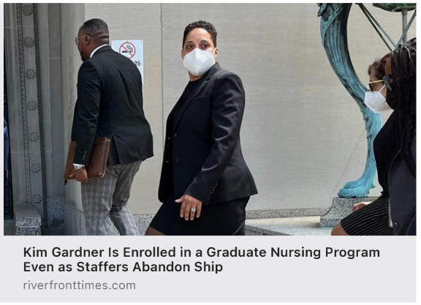

Wed, May 3, 4:47 PM

Mayor Jones
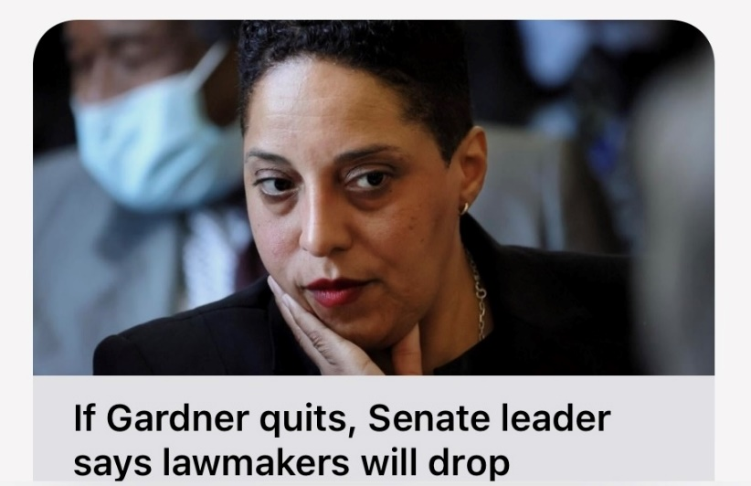

Richard Callow
Hahaha

Mayor Jones
I’ll believe it when I see it.
Richard Callow
Same
Virvus Jones
The new Mr. Obvious

Thu, May 4, 12:36 PM
Mayor Jones
Hearing rumors of a 2PM announcement
Richard Callow
Sta or go

Thursday, May 4, 2:05 PM
Mayor Jones
I see two camera crews outside the courthouse
Richard Callow
KMOV accidentally aired a graphic that she had resigned. They have since taken it down.
Mayor Jones
I swear, they can’t get shit right.
Nothing going on here and I’m tired of watching.

Richard Callow
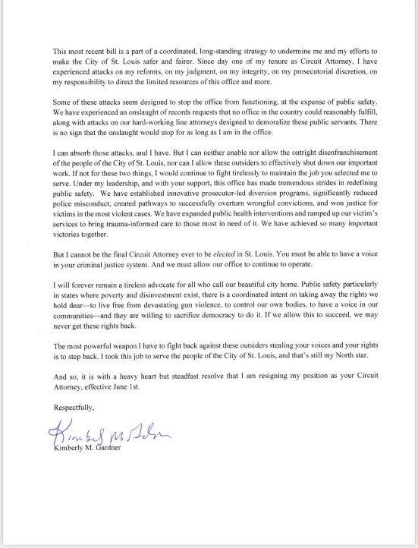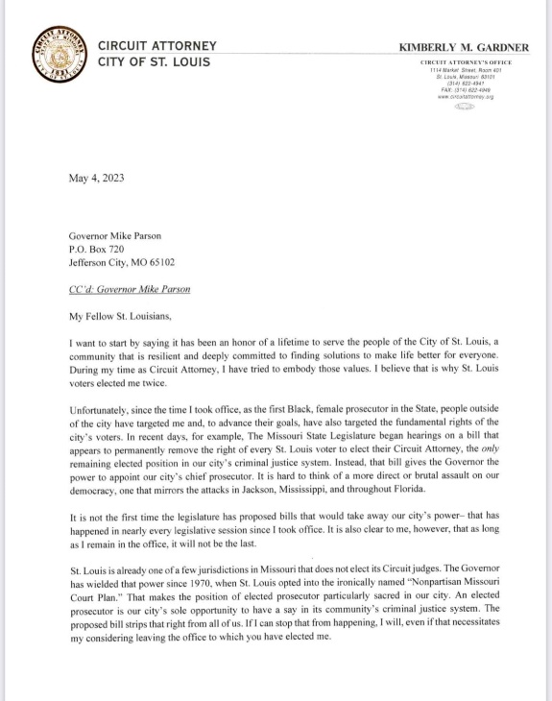
She’s announced her resignation. Effective June 1

Mayor Jones
On TV?
Richard Callow
Twitter
Here’s the President’s statement on CA’s resignation:
St. Louisans deserve a fair and just criminal justice system. There is no doubt that our system is in need of reform. But we can’t rely on today’s decision by the Circuit Attorney alone to solve the issues prevalent in our broken criminal justice system. We have to reduce conditions that lead to violent crimes in the first place. Addressing root issues creates a cascading effect-making resident safer and the Circuit Attorney’s office more effective in the cases it does prosecute. I am encouraged by Governor Parson’s readiness to work with local official in appointing a new Circuit Attorney. I’m calling on him to name a constructive partner who understands the needs and values of city residents.

Thu, May 4, 9:13 PM
Richard Callow
State Sen Steve Roberts tells me Gardner’s resignation “takes some of the wind out of the sails” of GOP bills that he’s said attacked St. Louis politically. If he’d have interest in a potential appointment as Interim CAL: “Right now my focus is on the last 6 days of session”
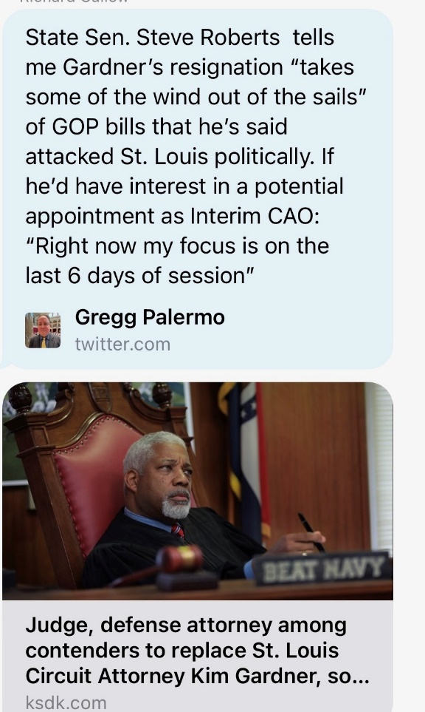

Fri, May 5, 12:06 PM
Richard Callow
Kim “press conference” is “going well”
Mayor Jones
Hahahah!

Fri, May 9, 2:09 PM

Richard Callow
Jennifer Joyce called me. She will do anything necessary to stop Steve Roberts. There is a personnel file.
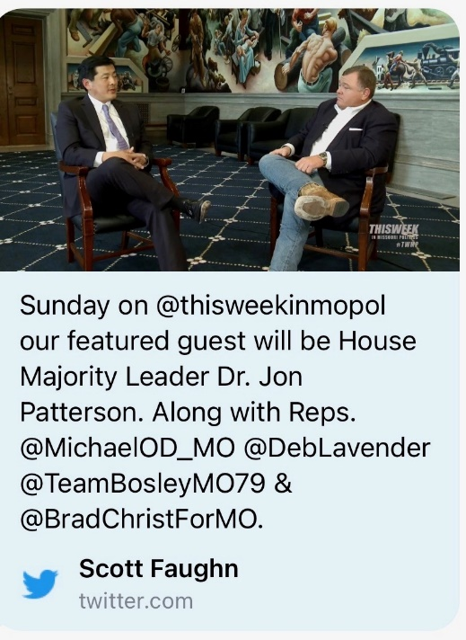
Look at the panel

Fri, May 5, 5:05 PM
Richard Callow
She is calling through her Rolodex of Republican prosecutors right now and is having them ask the governor to take her call. She is past president of the Mo Prosecutors. She has 1 message: no Steve

Mayor Jones
Bet!

Tue, May 9, 7:26 AM

Richard Callow

Mayor Jones
Do you know who satic1 square is.
Richard Callow
Nope

Virvus Jones
Somebody has been busy
Is it being distributed to the press?

Richard Callow
Yes
Mayor Jones
The Gov ain’t picking him. And we mobilize to make sure his ass gets dragged.
Virvus Jones
Yes

Richard Callow

Tue, May 9, 9:43 AM

Richard Callow
Circuit Attorney race
Tue, May 9, 2:21 PM

Mayor Jones
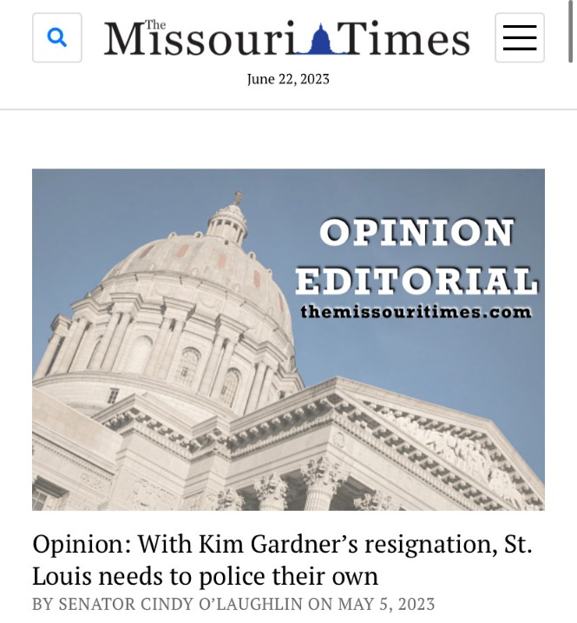
Please resist the urge to say anything about this crazy editorial. The only paragraph that makes sense is the last one.

Richard Callow
And the one before that

Mayor Jones
I was being generous
It basically says “Thanks for staying in STL even the we’re responsible for the horrific amount of guns on your streets.”

